Experiment-8

November 26, 2023

[2]:

Name: Adwait Purao UID: 2021300101 Batch: B2

**import pandas as pd import numpy as np**

**import matplotlib.pyplot as plt**

%matplotlib inline

[3]:

**from sklearn.cluster import** KMeans

**from sklearn.preprocessing import** StandardScaler

[64]:

df = pd.read_csv("/content/drive/MyDrive/Colab Notebooks/CC GENERAL.csv")

[10]:

df.head()

|  |  |  |  |  |  |  |
| --- | --- | --- | --- | --- | --- | --- |
| [10]: | CUST_ID | BALANCE | BALANCE_FREQUENCY | PURCHASES | ONEOFF_PURCHASES | \ |
|  | 0 C10001 | 40.900749 | 0.818182 | 95.40 | 0.00 |  |
|  | 1 C10002 | 3202.467416 | 0.909091 | 0.00 | 0.00 |  |
|  | 2 C10003 | 2495.148862 | 1.000000 | 773.17 | 773.17 |  |
|  | 3 C10004 | 1666.670542 | 0.636364 | 1499.00 | 1499.00 |  |
|  | 4 C10005 | 817.714335 | 1.000000 | 16.00 | 16.00 |  |

\

|  |  |  |  |  |
| --- | --- | --- | --- | --- |
|  | INSTALLMENTS_PURCHASES | CASH_ADVANCE PURCHASES_FREQUENCY | | \ |
| 0 | 95.4 | 0.000000 0.166667 | |  |
| 1 | 0.0 | 6442.945483 0.000000 | |  |
| 2 | 0.0 | 0.000000 1.000000 | |  |
| 3 | 0.0 | 205.788017 0.083333 | |  |
| 4 | 0.0 | 0.000000 0.083333 | |  |
| ONEOFF_PURCHASES_FREQUENCY PURCHASES_INSTALLMENTS_FREQUENCY | | | | |
| 0 | 0.000000 | | 0.083333 | |
| 1 | 0.000000 | | 0.000000 | |
| 2 | 1.000000 | | 0.000000 | |
| 3 | 0.083333 | | 0.000000 | |
| 4 | 0.083333 | | 0.000000 | |

CASH_ADVANCE_FREQUENCY CASH_ADVANCE_TRX PURCHASES_TRX CREDIT_LIMIT \

|  |  |  |  |  |
| --- | --- | --- | --- | --- |
| 0 | 0.000000 | 0 | 2 | 1000.0 |
| 1 | 0.250000 | 4 | 0 | 7000.0 |
| 2 | 0.000000 | 0 | 12 | 7500.0 |
| 3 | 0.083333 | 1 | 1 | 7500.0 |
| 4 | 0.000000 | 0 | 1 | 1200.0 |
| PAYMENTS MINIMUM_PAYMENTS PRC_FULL_PAYMENT TENURE | | | | |
| 0 201.802084 | 139.509787 | 0.000000 | 12 | |
| 1 4103.032597 | 1072.340217 | 0.222222 | 12 | |
| 2 622.066742 | 627.284787 | 0.000000 | 12 | |
| 3 0.000000 | NaN | 0.000000 | 12 | |
| 4 678.334763 | 244.791237 | 0.000000 | 12 | |

[11]:

df.tail()

|  |  |  |  |  |  |  |  |  |
| --- | --- | --- | --- | --- | --- | --- | --- | --- |
| [11]: |  | CUST_ID | BALANCE | BALANCE_FREQUENCY | | PURCHASES | ONEOFF_PURCHASES | \ |
|  | 8945 | C19186 | 28.493517 | 1.000000 | | 291.12 | 0.00 |  |
|  | 8946 | C19187 | 19.183215 | 1.000000 | | 300.00 | 0.00 |  |
|  | 8947 | C19188 | 23.398673 | 0.833333 | | 144.40 | 0.00 |  |
|  | 8948 | C19189 | 13.457564 | 0.833333 | | 0.00 | 0.00 |  |
|  | 8949 | C19190 | 372.708075 | 0.666667 | | 1093.25 | 1093.25 |  |
|  | | INSTALLMENTS_PURCHASES | | | CASH_ADVANCE | PURCHASES_FREQUENCY \ | | |
| 8945 | | 291.12 | | | 0.000000 | 1.000000 | | |
| 8946 | | 300.00 | | | 0.000000 | 1.000000 | | |
| 8947 | | 144.40 | | | 0.000000 | 0.833333 | | |
| 8948 | | 0.00 | | | 36.558778 | 0.000000 | | |
| 8949 | | 0.00 | | | 127.040008 | 0.666667 | | |
| ONEOFF_PURCHASES_FREQUENCY PURCHASES_INSTALLMENTS_FREQUENCY \ | | | | | | | | |
| 8945 | | 0.000000 | | | | 0.833333 | | |
| 8946 | | 0.000000 | | | | 0.833333 | | |
| 8947 | | 0.000000 | | | | 0.666667 | | |
| 8948 | | 0.000000 | | | | 0.000000 | | |
| 8949 | | 0.666667 | | | | 0.000000 | | |

|  |  |  |  |  |  |
| --- | --- | --- | --- | --- | --- |
|  | CASH_ADVANCE_FREQUENCY | CASH_ADVANCE_TRX | PURCHASES_TRX | CREDIT_LIMIT | \ |
| 8945 | 0.000000 | 0 | 6 | 1000.0 |  |
| 8946 | 0.000000 | 0 | 6 | 1000.0 |  |
| 8947 | 0.000000 | 0 | 5 | 1000.0 |  |
| 8948 | 0.166667 | 2 | 0 | 500.0 |  |
| 8949 | 0.333333 | 2 | 23 | 1200.0 |  |

|  |  |  |  |  |
| --- | --- | --- | --- | --- |
|  | PAYMENTS | MINIMUM_PAYMENTS | PRC_FULL_PAYMENT | TENURE |
| 8945 | 325.594462 | 48.886365 | 0.50 | 6 |

|  |  |  |  |
| --- | --- | --- | --- |
| 8946 275.861322 | NaN | 0.00 | 6 |
| 8947 81.270775 | 82.418369 | 0.25 | 6 |
| 8948 52.549959 | 55.755628 | 0.25 | 6 |
| 8949 63.165404 | 88.288956 | 0.00 | 6 |

[12]:

df.describe()

|  |  |  |  |  |  |  |  |
| --- | --- | --- | --- | --- | --- | --- | --- |
| [12]: |  | BALANCE | BALANCE_FREQUENCY | | PURCHASES | ONEOFF_PURCHASES | \ |
|  | count | 8950.000000 | 8950.000000 | | 8950.000000 | 8950.000000 |  |
|  | mean | 1564.474828 | 0.877271 | | 1003.204834 | 592.437371 |  |
|  | std | 2081.531879 | 0.236904 | | 2136.634782 | 1659.887917 |  |
|  | min | 0.000000 | 0.000000 | | 0.000000 | 0.000000 |  |
|  | 25% | 128.281915 | 0.888889 | | 39.635000 | 0.000000 |  |
|  | 50% | 873.385231 | 1.000000 | | 361.280000 | 38.000000 |  |
|  | 75% | 2054.140036 | 1.000000 | | 1110.130000 | 577.405000 |  |
|  | max | 19043.138560 | 1.000000 | | 49039.570000 | 40761.250000 |  |
| INSTALLMENTS_PURCHASES CASH_ADVANCE PURCHASES_FREQUENCY \ | | | | | | | |
| count | | 8950.000000 | | 8950.000000 | | 8950.000000 | |
| mean | | 411.067645 | | 978.871112 | | 0.490351 | |
| std | | 904.338115 | | 2097.163877 | | 0.401371 | |
| min | | 0.000000 | | 0.000000 | | 0.000000 | |
| 25% | | 0.000000 | | 0.000000 | | 0.083333 | |
| 50% | | 89.000000 | | 0.000000 | | 0.500000 | |
| 75% | | 468.637500 | | 1113.821139 | | 0.916667 | |
| max | | 22500.000000 | | 47137.211760 | | 1.000000 | |

|  |  |  |  |  |  |  |  |
| --- | --- | --- | --- | --- | --- | --- | --- |
|  | ONEOFF_PURCHASES_FREQUENCY | | PURCHASES_INSTALLMENTS_FREQUENCY | | | \ | |
| count | 8950.000000 | | 8950.000000 | | |  | |
| mean | 0.202458 | | 0.364437 | | |  | |
| std | 0.298336 | | 0.397448 | | |  | |
| min | 0.000000 | | 0.000000 | | |  | |
| 25% | 0.000000 | | 0.000000 | | |  | |
| 50% | 0.083333 | | 0.166667 | | |  | |
| 75% | 0.300000 | | 0.750000 | | |  | |
| max | 1.000000 | | 1.000000 | | |  | |
|  | CASH_ADVANCE_FREQUENCY | CASH_ADVANCE_TRX | | PURCHASES_TRX | CREDIT_LIMIT | | \ |
| count | 8950.000000 | 8950.000000 | | 8950.000000 | 8949.000000 | |  |
| mean | 0.135144 | 3.248827 | | 14.709832 | 4494.449450 | |  |
| std | 0.200121 | 6.824647 | | 24.857649 | 3638.815725 | |  |
| min | 0.000000 | 0.000000 | | 0.000000 | 50.000000 | |  |
| 25% | 0.000000 | 0.000000 | | 1.000000 | 1600.000000 | |  |
| 50% | 0.000000 | 0.000000 | | 7.000000 | 3000.000000 | |  |
| 75% | 0.222222 | 4.000000 | | 17.000000 | 6500.000000 | |  |
| max | 1.500000 | 123.000000 | | 358.000000 | 30000.000000 | |  |

|  |  |  |  |  |
| --- | --- | --- | --- | --- |
|  | PAYMENTS | MINIMUM_PAYMENTS | PRC_FULL_PAYMENT | TENURE |
| count | 8950.000000 | 8637.000000 | 8950.000000 | 8950.000000 |
| mean | 1733.143852 | 864.206542 | 0.153715 | 11.517318 |
| std | 2895.063757 | 2372.446607 | 0.292499 | 1.338331 |
| min | 0.000000 | 0.019163 | 0.000000 | 6.000000 |
| 25% | 383.276166 | 169.123707 | 0.000000 | 12.000000 |
| 50% | 856.901546 | 312.343947 | 0.000000 | 12.000000 |
| 75% | 1901.134317 | 825.485459 | 0.142857 | 12.000000 |
| max | 50721.483360 | 76406.207520 | 1.000000 | 12.000000 |

[40]:

*# Finding missing values* missing_data = df.isna() missing_counts = missing_data.sum() print(missing_counts)

[65]:

CUST_ID 0

BALANCE 0

BALANCE_FREQUENCY 0

PURCHASES 0

ONEOFF_PURCHASES 0

INSTALLMENTS_PURCHASES 0

CASH_ADVANCE 0

PURCHASES_FREQUENCY 0

ONEOFF_PURCHASES_FREQUENCY 0

PURCHASES_INSTALLMENTS_FREQUENCY 0

CASH_ADVANCE_FREQUENCY 0

CASH_ADVANCE_TRX 0

PURCHASES_TRX 0

CREDIT_LIMIT 1

PAYMENTS 0

MINIMUM_PAYMENTS 313

PRC_FULL_PAYMENT 0

TENURE 0

dtype: int64

df = df.drop("CUST_ID", axis=1)

*# Filling NaN with mean of the values*

df = df.fillna(df.mean())

*# For scaling the data*

scaler = StandardScaler()

data_scaled = scaler.fit_transform(df)

[46]:

missing_data = df.isna() missing_counts = missing_data.sum() print(missing_counts)

[66]:

BALANCE 0

BALANCE_FREQUENCY 0

PURCHASES 0

ONEOFF_PURCHASES 0

INSTALLMENTS_PURCHASES 0

CASH_ADVANCE 0

PURCHASES_FREQUENCY 0

ONEOFF_PURCHASES_FREQUENCY 0

PURCHASES_INSTALLMENTS_FREQUENCY 0

CASH_ADVANCE_FREQUENCY 0

CASH_ADVANCE_TRX 0

PURCHASES_TRX 0

CREDIT_LIMIT 0

PAYMENTS 0

MINIMUM_PAYMENTS 0

PRC_FULL_PAYMENT 0

TENURE 0

Cluster 0

dtype: int64

Using Elbow method to find optimal k

inertia = []

**for** k **in** range(1, 11):

kmeans = KMeans(n_clusters=k, random_state=101, n_init=10) kmeans.fit(data_scaled)

inertia.append(kmeans.inertia_)

*# Plot the Elbow curve* plt.figure(figsize=(8, 5)) plt.plot(range(1, 11), inertia, marker="o") plt.title("Elbow Method for Optimal K") plt.xlabel("Number of Clusters (K)") plt.ylabel("Inertia")

plt.show()

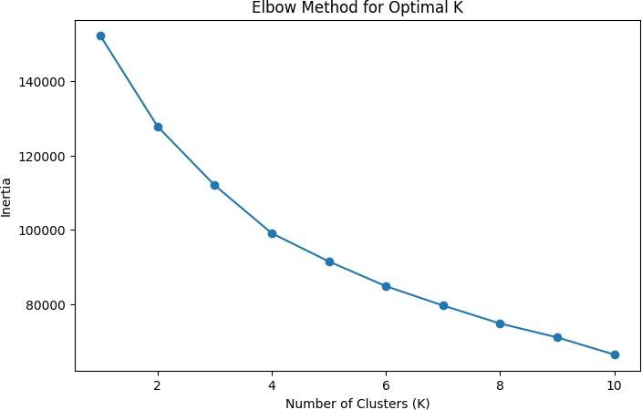

Verifing Silhoute Score to get the optimal K

[67]:

**from sklearn.metrics import** silhouette_score

silhouette_scores = [] K_range = range(2, 11) **for** k **in** K_range:

kmeanModel = KMeans(n_clusters=k,random_state=101,n_init = 10) kmeanModel.fit(df)

labels = kmeanModel.labels_

silhouette_avg = silhouette_score(df, labels) silhouette_scores.append(silhouette_avg)

*# Plot silhouette scores*

plt.figure(figsize=(8, 4))

plt.plot(K_range, silhouette_scores, marker='o') plt.title('Silhouette Score for Optimal k') plt.xlabel('Number of clusters') plt.ylabel('Silhouette Score')

plt.show()

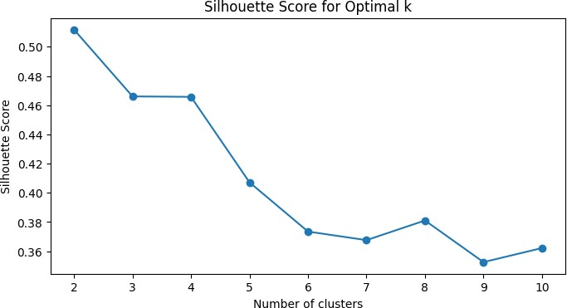

Since we the silhoute score for k = 2 is the highest, we choose k = 2 as the optimal k.

[59]:

optimal_k = 2

kmeans = KMeans(n_clusters=optimal_k, random_state=101, n_init=10) df["Cluster"] = kmeans.fit_predict(data_scaled)

[60]:

*# Analyze the characteristics of each cluster* cluster_means = df.groupby("Cluster").mean() cluster_means

[60]: BALANCE BALANCE_FREQUENCY PURCHASES ONEOFF_PURCHASES \

|  |  |  |  |  |  |
| --- | --- | --- | --- | --- | --- |
| Cluster 0 | 1378.130586 | 0.945460 2024.075484 | | | 1141.435320 |
| 1 | 1697.139951 | 0.828725 276.410541 | | | 201.586115 |
| INSTALLMENTS_PURCHASES CASH_ADVANCE PURCHASES_FREQUENCY \ | | | | | |
| Cluster 0 | 882.969151 | | 435.925695 | | 0.904712 |
| 1 | 75.104101 | | 1365.413355 | | 0.195352 |
| Cluster | ONEOFF_PURCHASES_FREQUENCY | | | PURCHASES_INSTALLMENTS_FREQUENCY \ | |
| 0 | 0.362118 | | | 0.730082 | |
| 1 | 0.088790 | | | 0.104122 | |

Cluster

CASH_ADVANCE_FREQUENCY CASH_ADVANCE_TRX PURCHASES_TRX \

|  |  |  |  |  |
| --- | --- | --- | --- | --- |
| 0 |  | 0.058397 | 1.411069 | 30.657174 |
| 1 |  | 0.189783 | 4.557192 | 3.356350 |
| Cluster | CREDIT_LIMIT | PAYMENTS | MINIMUM_PAYMENTS | PRC_FULL_PAYMENT \ |
| 0 | 5095.773845 | 2184.020580 | 872.555375 | 0.270892 |
| 1 | 4066.345128 | 1412.148599 | 858.262710 | 0.070292 |
| Cluster | TENURE |  |  |  |
| 0 | 11.674637 |  |  |  |
| 1 | 11.405318 |  |  |  |

[61]:

selected_clusters = [0, 1]

plt.figure(figsize=(10, 6))

**for** cluster **in** selected_clusters:

cluster_data = df[df["Cluster"] == cluster] plt.scatter(

cluster_data["BALANCE"], cluster_data["PURCHASES"], label=f"Cluster␣

↪**{**cluster**}**"

)

plt.title("Scatter Plot of Clusters") plt.xlabel("Balance") plt.ylabel("Purchases")

plt.legend() plt.show()

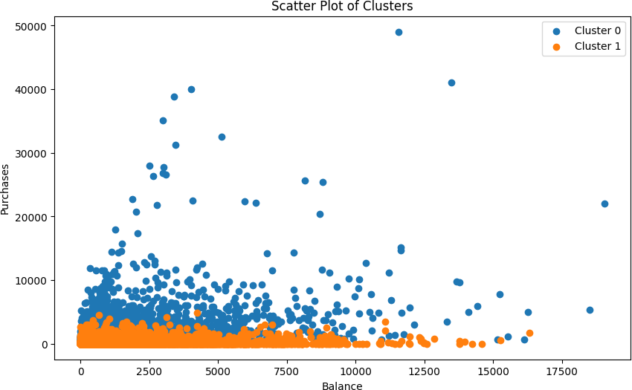

Analyzing the Cluster Produced

The presented plot demonstrates the segmentation of data points into two distinct clusters. In Cluster 1, individuals exhibit low spending scores, while in Cluster 0, individuals are character- ized by high spending scores. This binary clustering suggests a clear division between those with relatively conservative financial behaviors (Cluster 1) and those with more extravagant spending habits (Cluster 0).